The Noble Man DBMS

* mysql -u root -p



* SHOW DATABASES; 🡪 used to display all the databases in your system

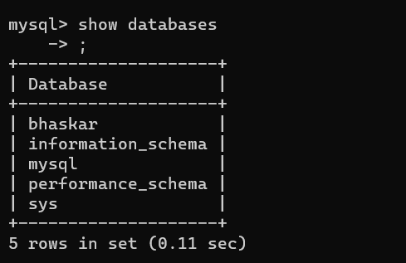

* CREATE DATABASE 🡪 used to create a database in your system

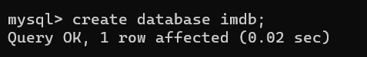

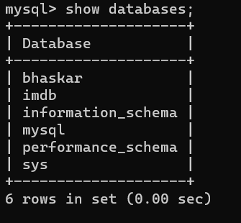

* USE 🡪 used to change the database



* SHOW TABLES 🡪 use to display all the tables in your database

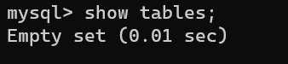

//Since, we have not create any table in the databse.

* Datatypes in SQL

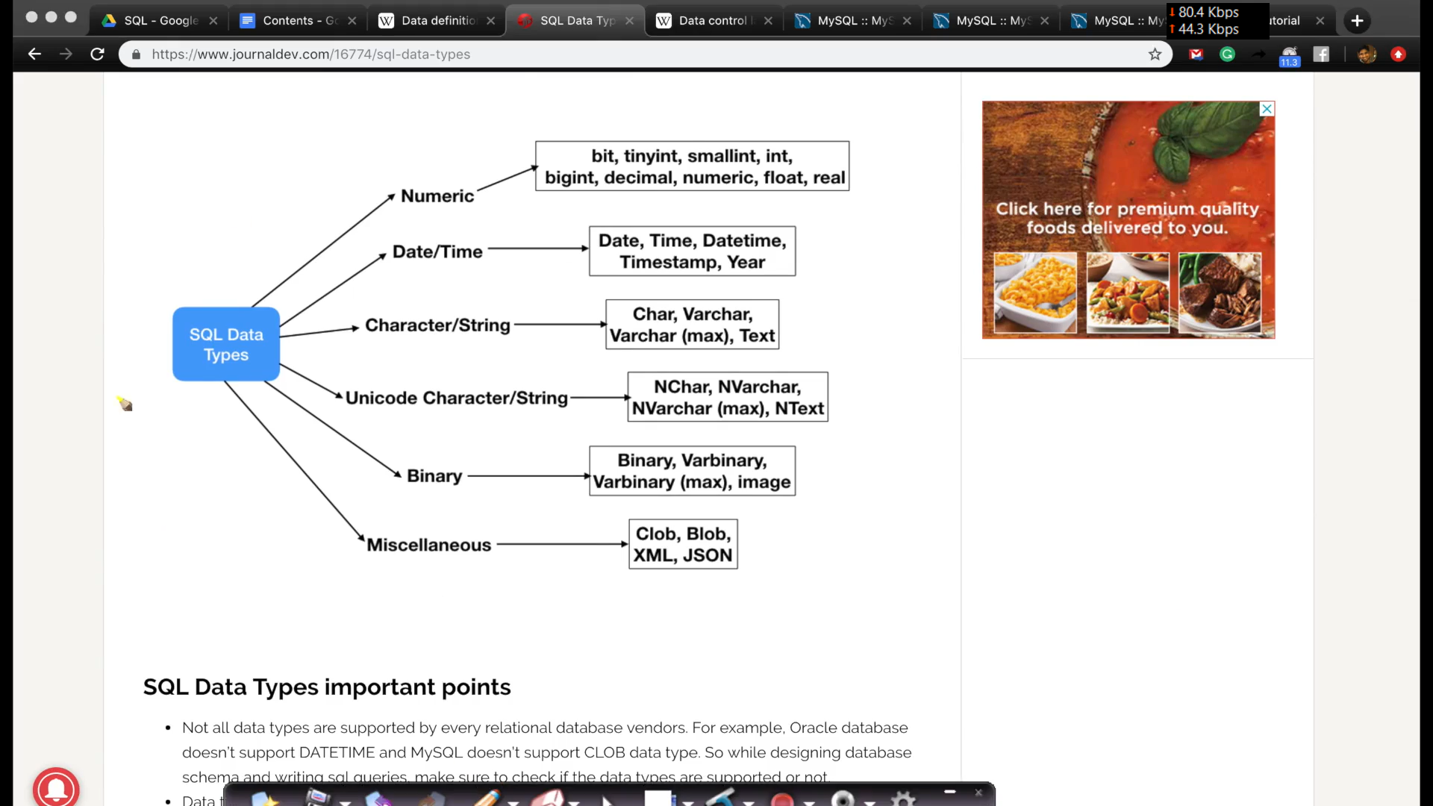

* Constraints in SQL

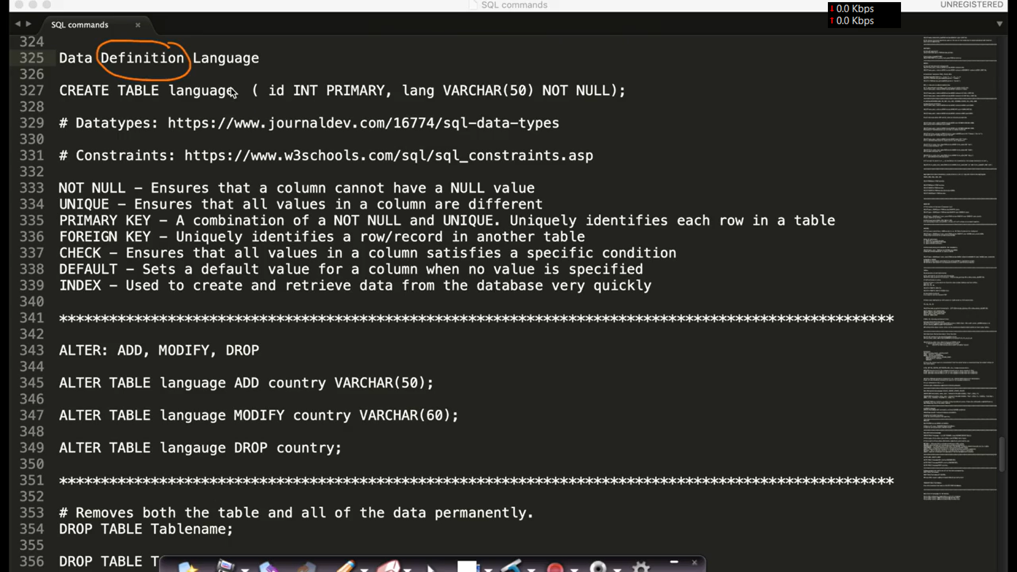

* Commands in SQL

1. Data Definition Language(DDL)
2. CREATE TABLE 🡪 used to create a table



NOTE : DESC 🡪 used to show the structure of table.

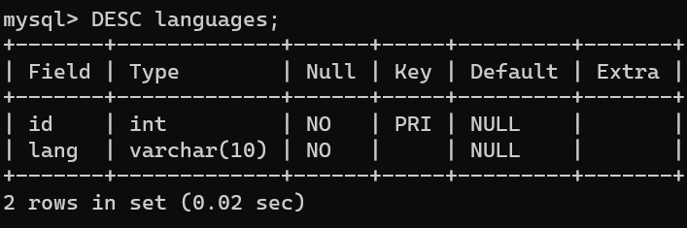

1. ALTER TABLE 🡪 used to add , modify and drop a column in a table

* ADD COLUMN

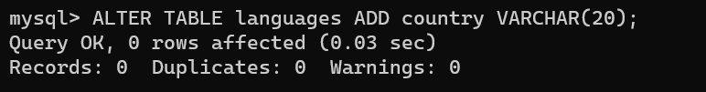

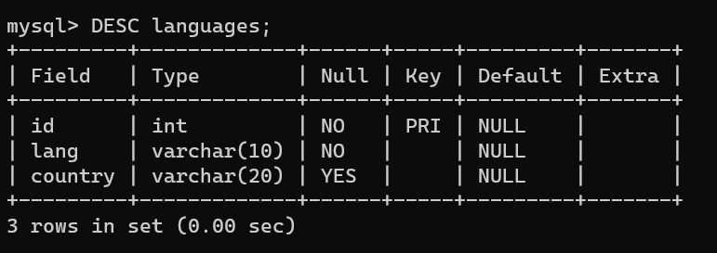

* MODIFY COLUMN

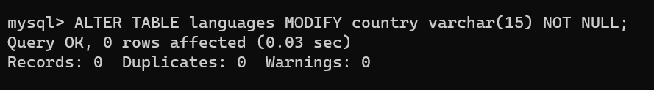

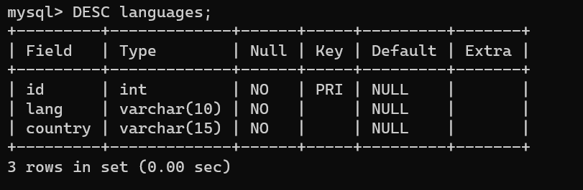

* DROP COLUMN

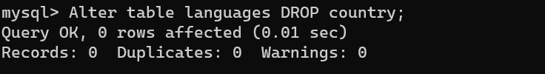

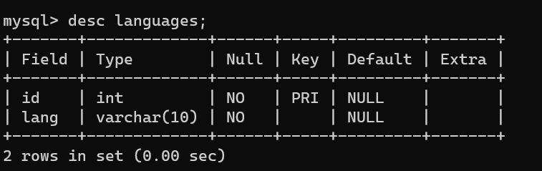

1. TRUNCATE TABLE 🡪 used to DELETE/REMOVE all the rows in a table



NOTE : TRUNCATE is same as DELETE without a WHERE clause

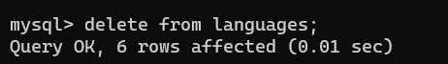

1. DROP TABLE 🡪 used to DELETE the entire table



//Adding More Columns to the existing table

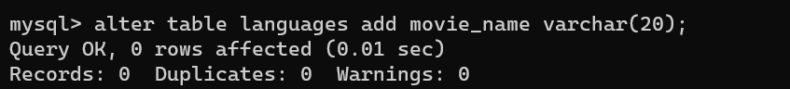

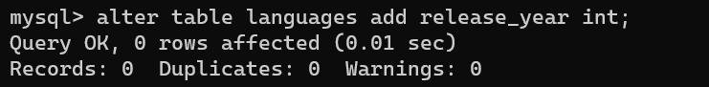

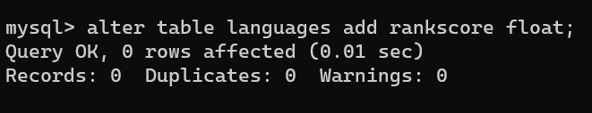

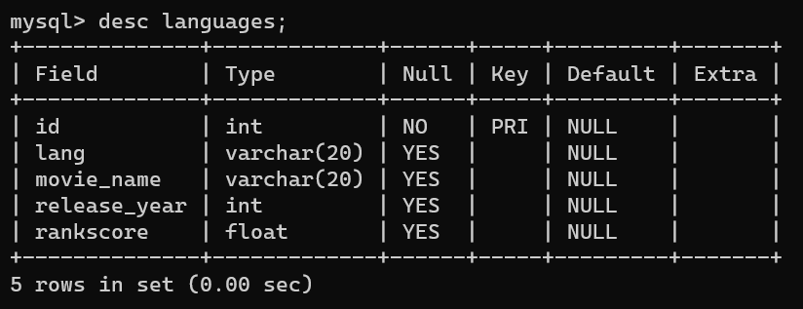

1. Data Manipulation Language(DML)
2. INSERT TABLE 🡪 used to insert new records in a table

//Inserting Single record(row) at a time



//Inserting Multiple records(rows) at a time



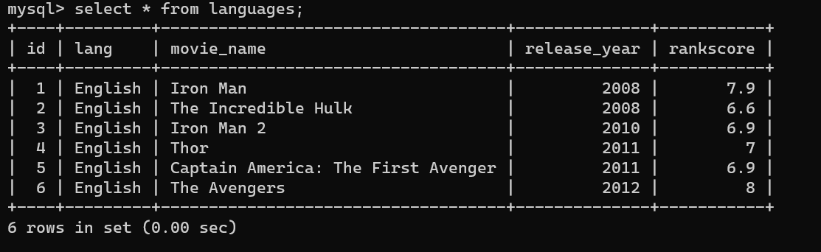

1. UPDATE TABLE 🡪 used to modify the existing records in a table

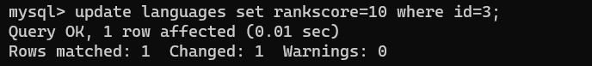

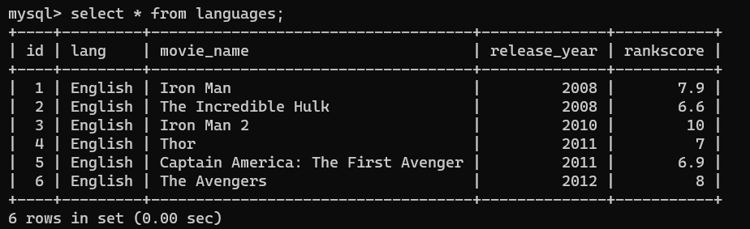

1. DELETE TABLE 🡪 used to delete the existing records in a table



